**CSC 600**

**Homework #3**

Parker Gray

10/15/2017

1.) Family w/ Lists

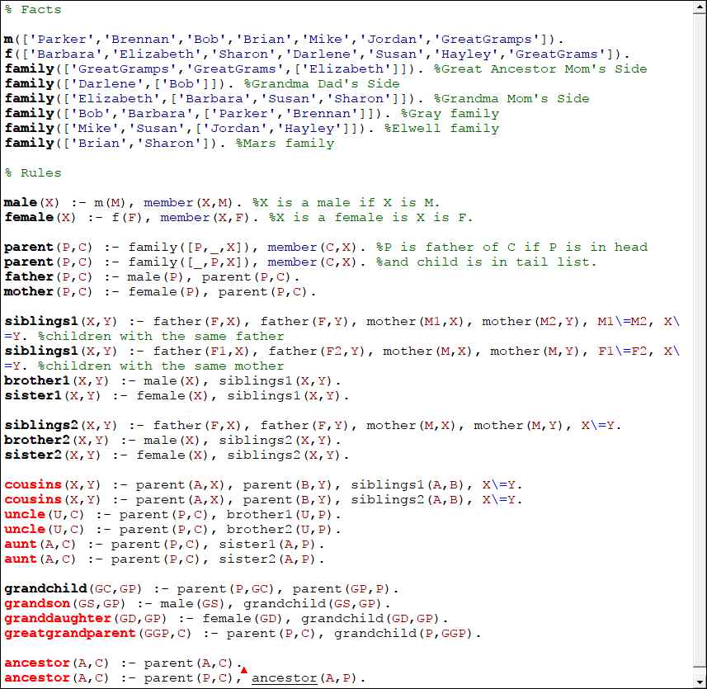

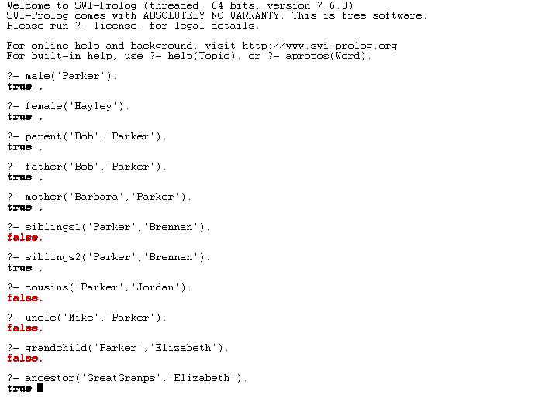

Of these, only cousin/uncle/aunt and grandparent methods return false Boolean values.

2. List Operations

Most of these rules were in the lecture notes, so I used those implementations. Not sure if this is disallowed or not…

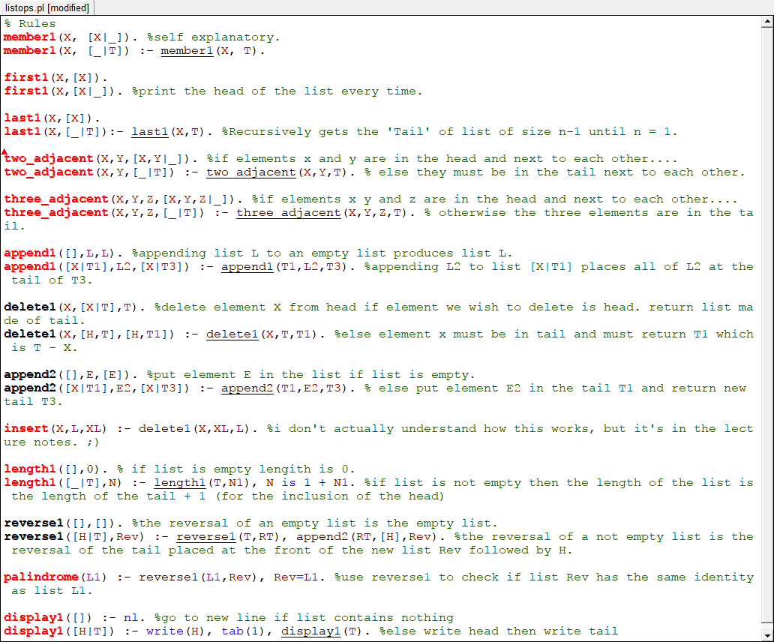

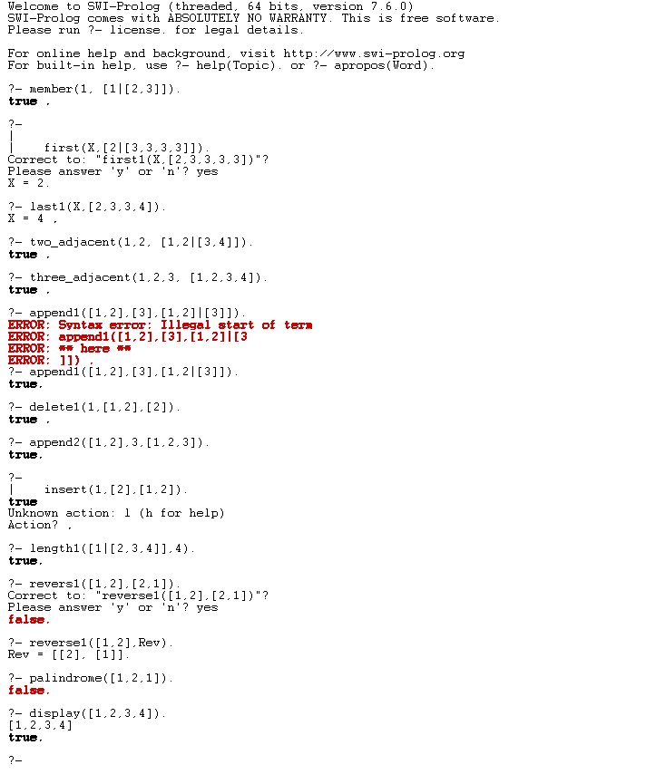

Not sure why palindrome is not working correctly.

3. 8 Queens Problem

